Pregame Timeline
When | What
<Locker Room> | Pregame discussion. <my cheat sheet is at the end of this document>
+ 15 minutes | On the floor. Count players. Start checking for uniform/jewlery violations – let coaches know, not players. (Note: Headphones are not legal equipment.)
+12 minutes | Captains meeting then head to table to pre-emptively address problems before they are problems…no one likes to start with a T if avoidable  - Are rosters and starters at table even if not in book? If so then the requirement is met.  - Count number of players in book vs. what you and your partners counted. If no match, count again. If there is a difference – fix it now  - Have them run shot clock so a) you can hear the buzzer and b) make sure it’s working (if not working then controller likely not all the way plugged in)  - Identify who is clock/shot/book. Make sure they are comfortable with the responsibilities and then go tell your partners who they are.)
+10 minutes | Check book. If you have done steps above, and you know it’s settled – I like to draw line in empty slot below last player so I know if changes are made later.  Put last names of officials in the book.  Get a game ball if one is not at the table.
+2 minutes | Meet coaches – visiting team first. Cover:  - Identify head coach (so you know who can stand…bonus points if you check online or discuss with partners so you know before you hit the floor)  - Trainer or not? - “do you have a medical professional trained in concussion management?” if visitors they will likely say they are using the home team. Know the rules if there isn’t one present  - “All your players legally and properly equipped?” (this includes undershirts)  - Point out coaching box  - Ask if they have any questions?  Remember they are not looking to have a conversation with you no more than you want one with them….we are hitting them right before they meet with their team to start the game….keep it brief and the later in the season it gets the quicker it will go.

2025-26 Pregame Discussion Guide
2025-26 POEs
- Contact on ball handler
- Bench Decorum/communication/Player Altercations
- Faking Being Fouled - Not = not a flop, contact = foul
2025-26 Rules Changes
- Designated throw in spots
- Basket interference – slap on same side
- Goaltending - No offensive | once ball hits board it’s downward flight
- Definition of player/bench during time out
- Thrower delaying return
2024-25 Rules Changes (reminder)
- Coach/bench personnel enters court – sub out or time out
- 20 seconds to address blood – or time out to keep player in
- BI – net touch ok if no contact with ball
- Delay for providing ball to official – warning vs T
- Pregame admin/team/bench T’s offset, start game with jump,
- Dunking dead ball is a team technical
Absolutes
- No double mark 3’s – center drop if it happens
- As lead, ask for help on OB on opposite side
- Lead first crack at block/charge on drive to basket
- Bench decorum - talk/warning/technical
  - Out of box – coaching or disrespecting?
  - Question integrity, continual criticism
  - Profanity/derogatory language/Gesturing,
  - Response to no call - prolonged negative, aggressive/hostile
Crew Alignment
- First Five minutes – set the tone. Don’t box us in. S/D/F/D
- Trust the system – own your primary, oh sh*t to come out of it
- Control physicality - let’s try to talk them out of contact we don’t like
  - off-ball- call that prevent movement w/or w/o ball
  - Offense initiated contact of defender with LGP
  - Post play – mutual contact? Advantage gained?
- Clock awareness – shot, end of period
- Technical foul – talk to a partner before you report
- No 3 person conference if players aren’t sent to the benches

What do we know about the teams? (If anything)
Any interesting plays or situations we want to talk about?

Reminders
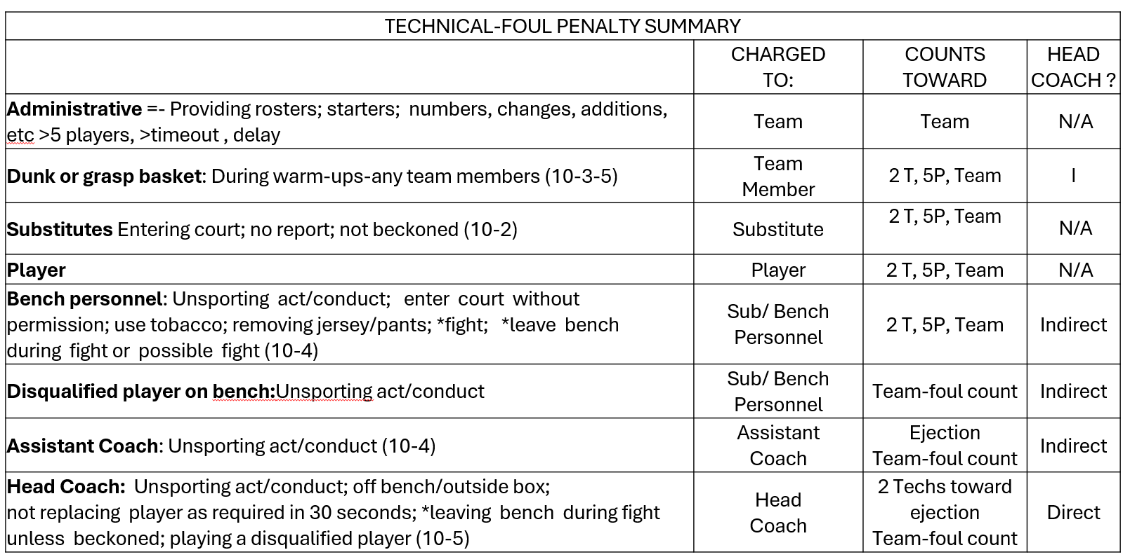
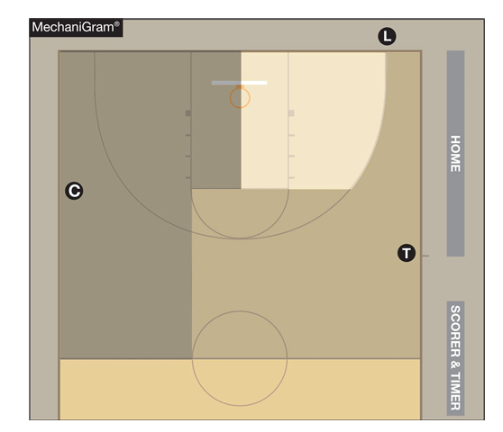
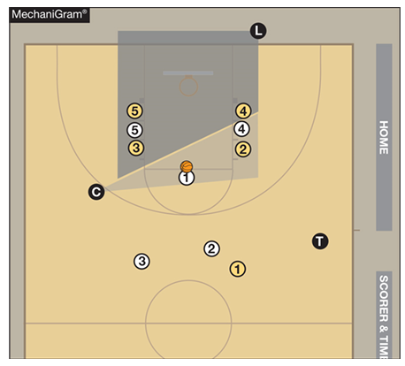

Correctable errors BEFORE the ball becomes live AFTER the next dead ball.  - Failure to award a merited FT.  - Awarding an unmerited FT.  - Permitting the wrong player to attempt a FT.  - Attempting a FT at the wrong basket.  - Mistakenly cancelling or counting a score.  The Four ID’s:  - Identify the error did in fact occur and when it occurred.  - Identify when the ball was at the disposal of the thrower-in (the ball is now live.)  - Identify the clock had properly started (in FT matters the clock would have been stopped) and play ensues.  - Identify if you were notified before the ball became live following a score or a violation. | 